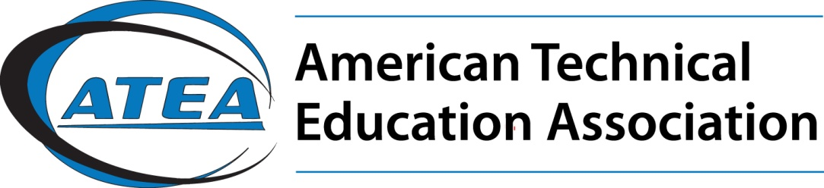

**ATEA Membership | 2023**

**What is the American Technical Education Association?**

ATEA is an autonomous, non-affiliated international association devoted solely to the purposes of postsecondary technical education. It is an organization dedicated to excellence in the quality of postsecondary technical education with emphasis on professional development. ATEA is a driving force behind workforce development.

ATEA was founded in Delmar, New York in 1928 and incorporated as a non-profit professional education association in 1960. In 1973 the national headquarters moved from New York to Wahpeton, North Dakota to the campus of North Dakota State College of Science. In 2012 the national office moved to Dunwoody College of Technology, a private non-profit technical college founded in 1914 in Minneapolis.

**Members:**

* Teach, serve or administer technical education at the postsecondary level.
* Hire technically prepared employees
* Support or provide technical education pathways: secondary to postsecondary or postsecondary to university levels.

**Mission:**

The American Technical Education Association (ATEA) is  
a leading association for the postsecondary technical educator with emphasis on professional development.  
The organization is dedicated to excellence in quality of postsecondary technical education focusing on practical teaching ideas and best practices. ATEA recognizes outstanding performance and leadership and provides a network for career connectivity.

**Goals:**

* Promote high quality technical education.
* Advocate the value of technical education to society.
* Disseminate information regarding current issues, trends and exemplary practices in technical education.
* Partner with educational institutions, business, industry, labor and government to enhance workforce development strategies.

**Top Ten Reasons to Join ATEA:**

10. Workforce Development

9. Voice for technical and applied education

8. Savings on a variety of insurance programs

7. Active involvement with business and industry

6. Links to member institutions via the ATEA Web site

5. Subscription to the ATEA Journal

4. Regional and national conferences

3. Awards for outstanding performance and leadership

2. Professional growth and development

1. Networking with technical education professionals

**Annual Membership Rates:**

Individual Members $100

Individual Life Membership $600

Institutional Members (6) $500

Supporting Institutional (15) $1000

System memberships (100) $5000

Corporate/Business Members $1000-5000

**American Technical Education Assn.**

Dr. Sandra Krebsbach

Executive Director, ATEA

skrebsbach@dunwoody.edu | 612.381.3315

Dunwoody College of Technology

818 Dunwoody Blvd

Minneapolis, MN 55304

**www.ateaonline.org**

**To join online or print a membership form, please visit:** [**www.ateaonline.org/Membership**](http://www.ateaonline.org/Membership)

Email questions on membership to: ateacommunications@gmail.com

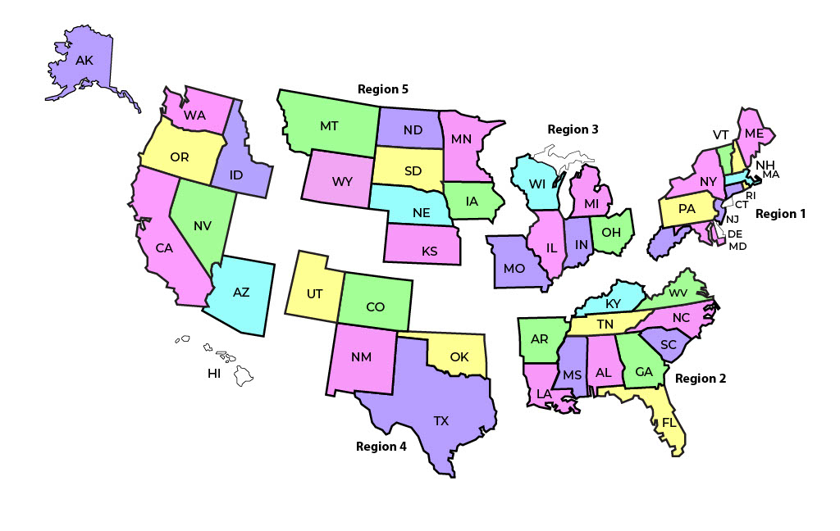

ATEA Sectors 2023

Aerospace and Space

Agriculture and Natural Resource

Allied Health

Construction

Energy

Information Technology

Manufacturing

Transportation

**Board of Trustees**

**President**

Dr. Betty Reynard, President, Lamar State College Port Arthur | Port Arthur TX

**Vice President and President Elect**

Dr. Ann Bolman, 2nd VP, President Western Dakota Technical College | Rapid City SD

**Executive Committee Members of the Board of Trustees**

Immediate Past President, Dr. Jon Connolly, President, Sussex County Community College | Newton, NJ

Ryan Purdy, 2nd VP, President Mid-Plains Community College l North Platte NE

Bob Wallace, Treasurer, Trustee Emeritus Retired Tennessee Colleges of Applied Technology | Nashville TN

Past Presidents Council, Dr. Rich Wagner, President Dunwoody College of Technology l MPLS M

Sue Smith, Past President, Vice President, Advanced Manufacturing, Engineering and Applied Science, Ivy Tech CC l IN

James King, Past President, retired President of Northeast CC, TN and Vice Chancellor Tennessee Colleges of Applied Tech

Dr. Sandra Krebsbach, ATEA, national office Dunwoody College of Technology | Minneapolis MN

**Board of Trustees**

Dr. Brian Bontempo, Superintendent, Auburn Career Center and Ohio Tech Center l Auburn OH

Victor Branch, retired Manager of Education and Digital Tools, Mississippi State College CAVS Extension l Canton MS

Al Bunshaft, retired, SVP Dassault Systems and President of DS Foundations l Waltham MA

Dr. Sandy Caldwell, Ex. Director, Wyoming Community College Commission, Cheyenne WY

Elizabeth Colbert-Busch, Economic Development Adviser to President of Trident Technical College l Charleston SC

Dr. David Dore, Chancellor, Virginia Community Colleges Commission

Dr. Aaron Fichtner, President of New Jersey County College Council l Trenton NJ

Dr. Jimmy Hodges, President Calhoun Community College l Decatur AL

Anthony Landis, Senior Director College Access and Career Success Ohio Department of Higher Education l Columbus OH

Brooks Jacobsen, Instructor, Robotics and Electronics, Lake Area Technical College l Watertown SD

J P Laguerre, Director, Education, 3 D Experience, Dassault Systemes of America l Long Beach CA

Paul Perkins, President, and CEO of Amatrol l Jeffersonville IN

Ken Potthoff, Deputy Executive Director CTECS | Decatur GA

Dr. Brad Tyndall, President Wyoming Central College, Riverton WY

Chelle Travis, Executive Director, SkillsUSA l Leesburg VA

Dr. Sheree Utash, President Wichita State University Tech l Wichita KS

Cliff Wightman, President Tennessee College of Applied Technology-Crossville l Crossville TN

Dr. Lin Zhou, President Bates Technical College l Tacoma WA

Dana Wolff, Past President of ATEA Regions, retired Instructor of Finance and Entrepreneurship, Southeast Tech, Sioux Falls, SD